**CRAIG instructions:**

Frame assignment for craig:

1. label all links, link0, link1, link2, linkn
2. Label all joints, joint1, joint 2, … jointn
3. Assign frame 0 freely, and attached to frame 0.
4. Assign zi along joint_i, etc.
5. Assign xi as the common normal between zi and zi+1
6. complete the D&H table

a_i is the distance from zi to zi+1 about xi(-1)

alpha_i is the angle from zi to zi+1 about xi(-1)

di is the distance from xi-1 to xi about zi

theta_i I the angle from xi-1 to xi about zi

a_i-1 distance from z_i-1 to z_i along x_i-1

Example:

**SMOKIE ARM robot Example: AUBO OUR i5**

**Craig-based frame assignment**

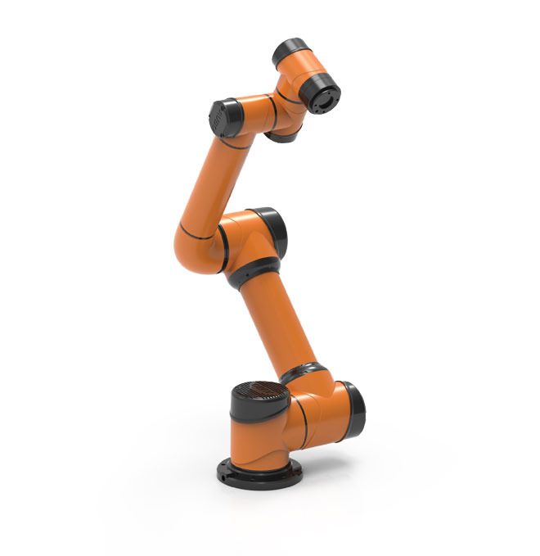

zo z1

xo

z2

x1

z3

x3

z5

z4

z6

x4

x5

x4

x6

x2

D&H:

|  |  |  |  |  |
| --- | --- | --- | --- | --- |
| *i* | *ai* | *i* | *di* | *i* |
| 1 | 0 | 90 | d1 | 1* |
| 2 | a2 | 0 | d2 | 2* |
| 3 | a3 | 0 | d3 | 3* |
| 4 | 0 | 90 | d4 | 4* |
| 5 | 0 | 90 | d5 | 5* |
| 6 | 0 | 0 | d6 | 6* |

Forward Kinematics

Frame assignment for craig:

1. label all links, link0, link1, link2, linkn
2. Label all joints, joint1, joint 2, … jointn
3. Assign frame 0 freely, and attached to frame 0.
4. Assign zi along joint_i, etc.
5. Assign xi as the common normal between zi and zi+1
6. complete the D&H table